**Project Under Test: MonkeySim**

Ritika Maknoor

David Bickford

10 November 2016

**CS 1632 - DELIVERABLE 4: Performance Testing Using VisualVM**

**SUMMARY**

______________________________________________________________________

*Summary*

**SCREENSHOTS OF VISUALVM**

______________________________________________________________________

**BEFORE any refactoring**

**Initial monkey: 4**

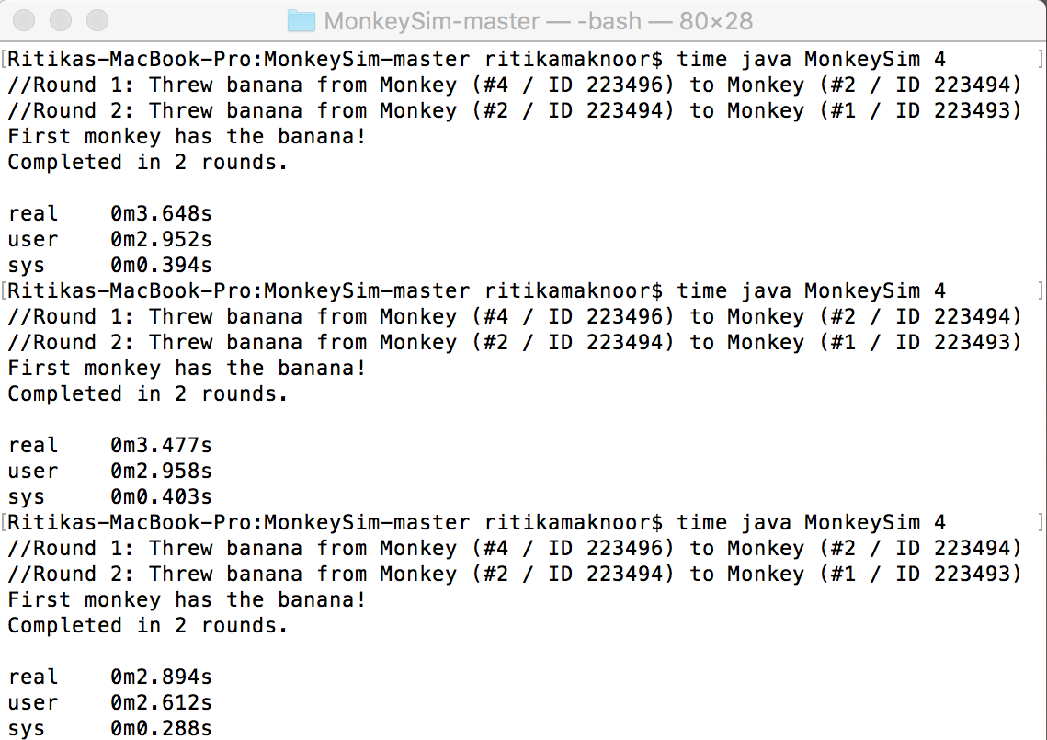

* Max amount of real time: 0m3.648s
* Mean time of real time: 0m3.340s

_________________________________

**AFTER refactoring stringifyResults()**

**Initial monkey: 4**

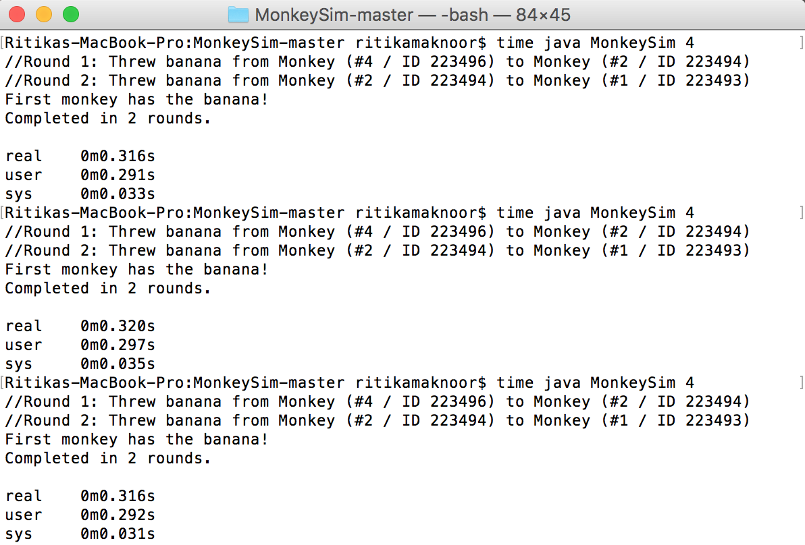

* Max amount of real time: 0m0.320s
* Mean time of real time: 0m0.317s

_________________________________

**AFTER refactoring getFirstMonkey()**

**Initial monkey: 4**

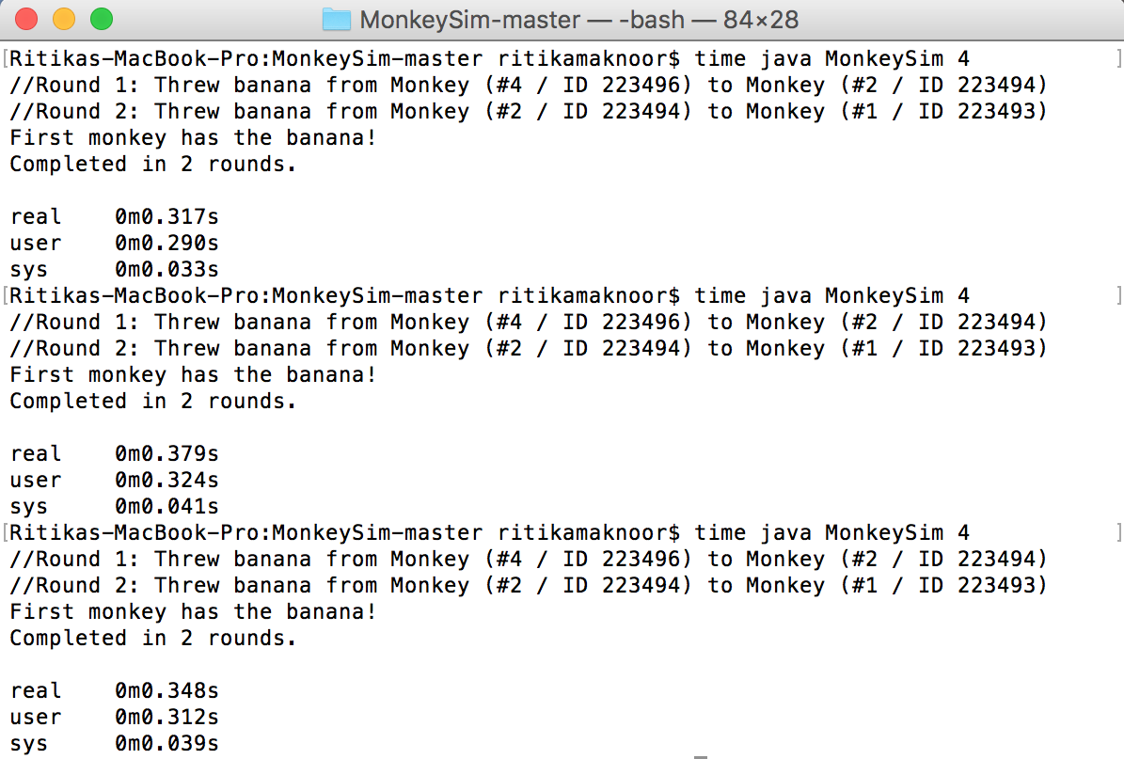

* Max amount of real time: 0m0.379s
* Mean time of real time: 0m0.348s

_________________________________

**AFTER refactoring generateID()**

**Initial monkey: 4**

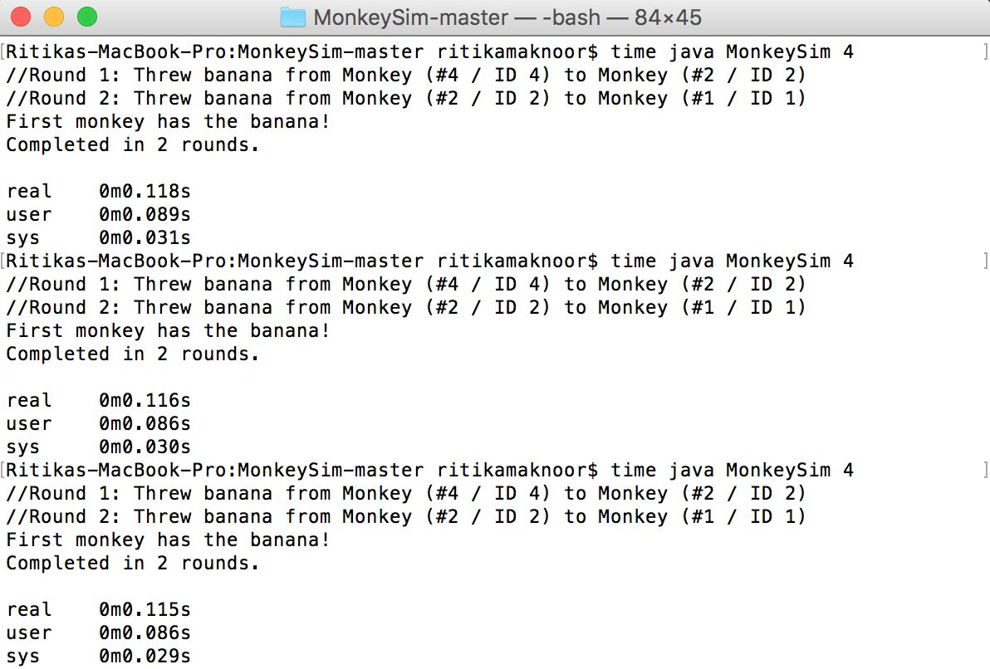

* Max amount of real time: 0m0.118s
* Mean time of real time: 0m0.116s

_________________________________

**BEFORE any refactoring**

**Initial monkey: 50**

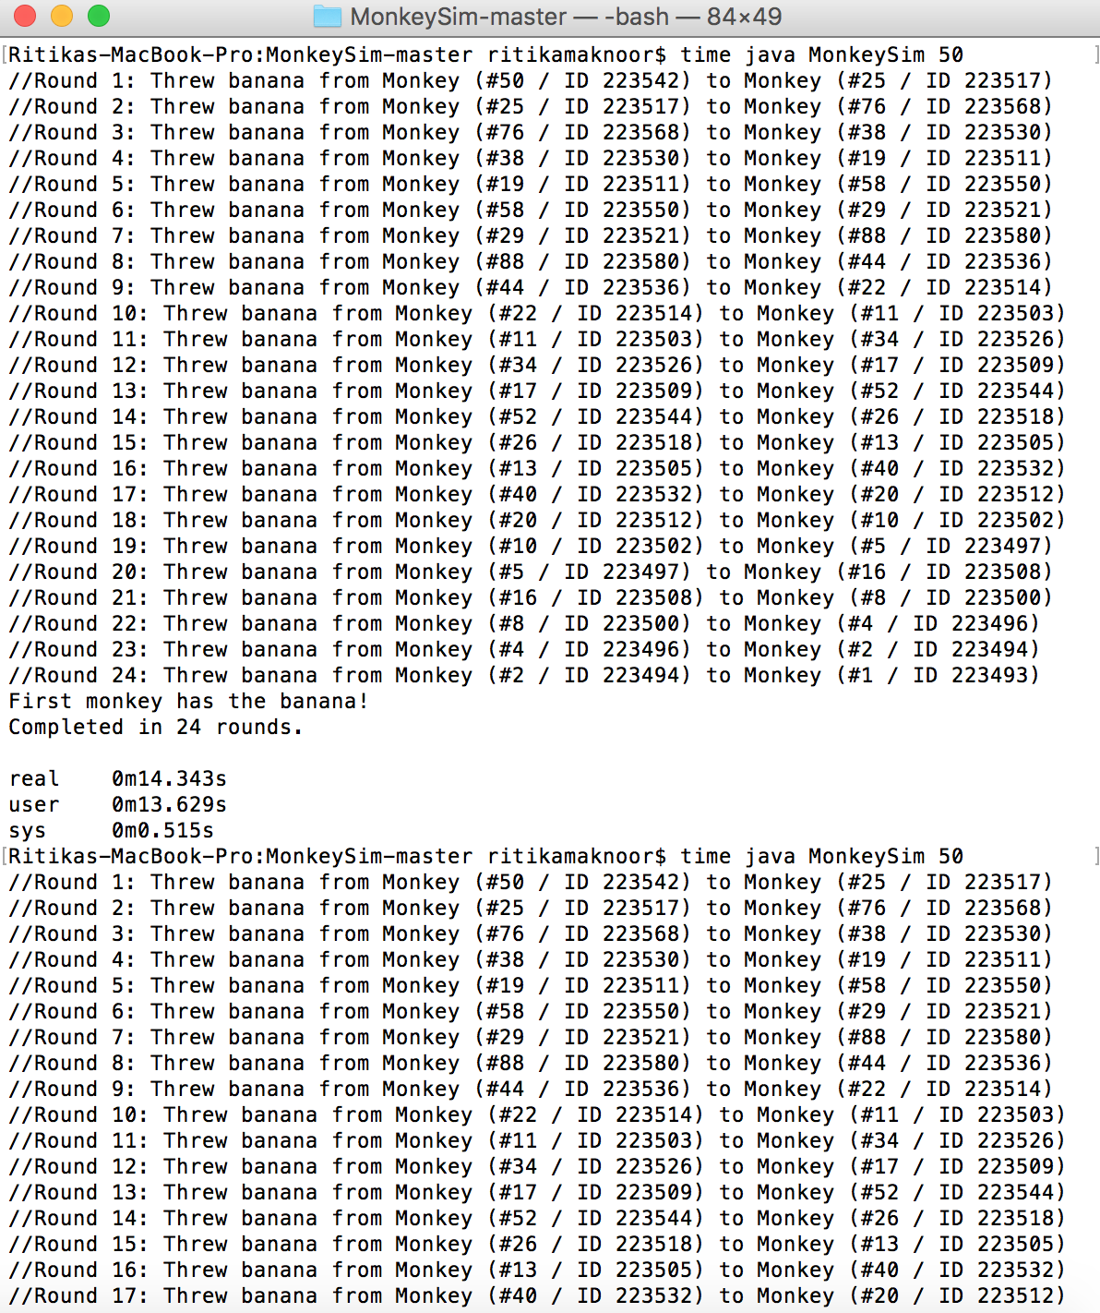

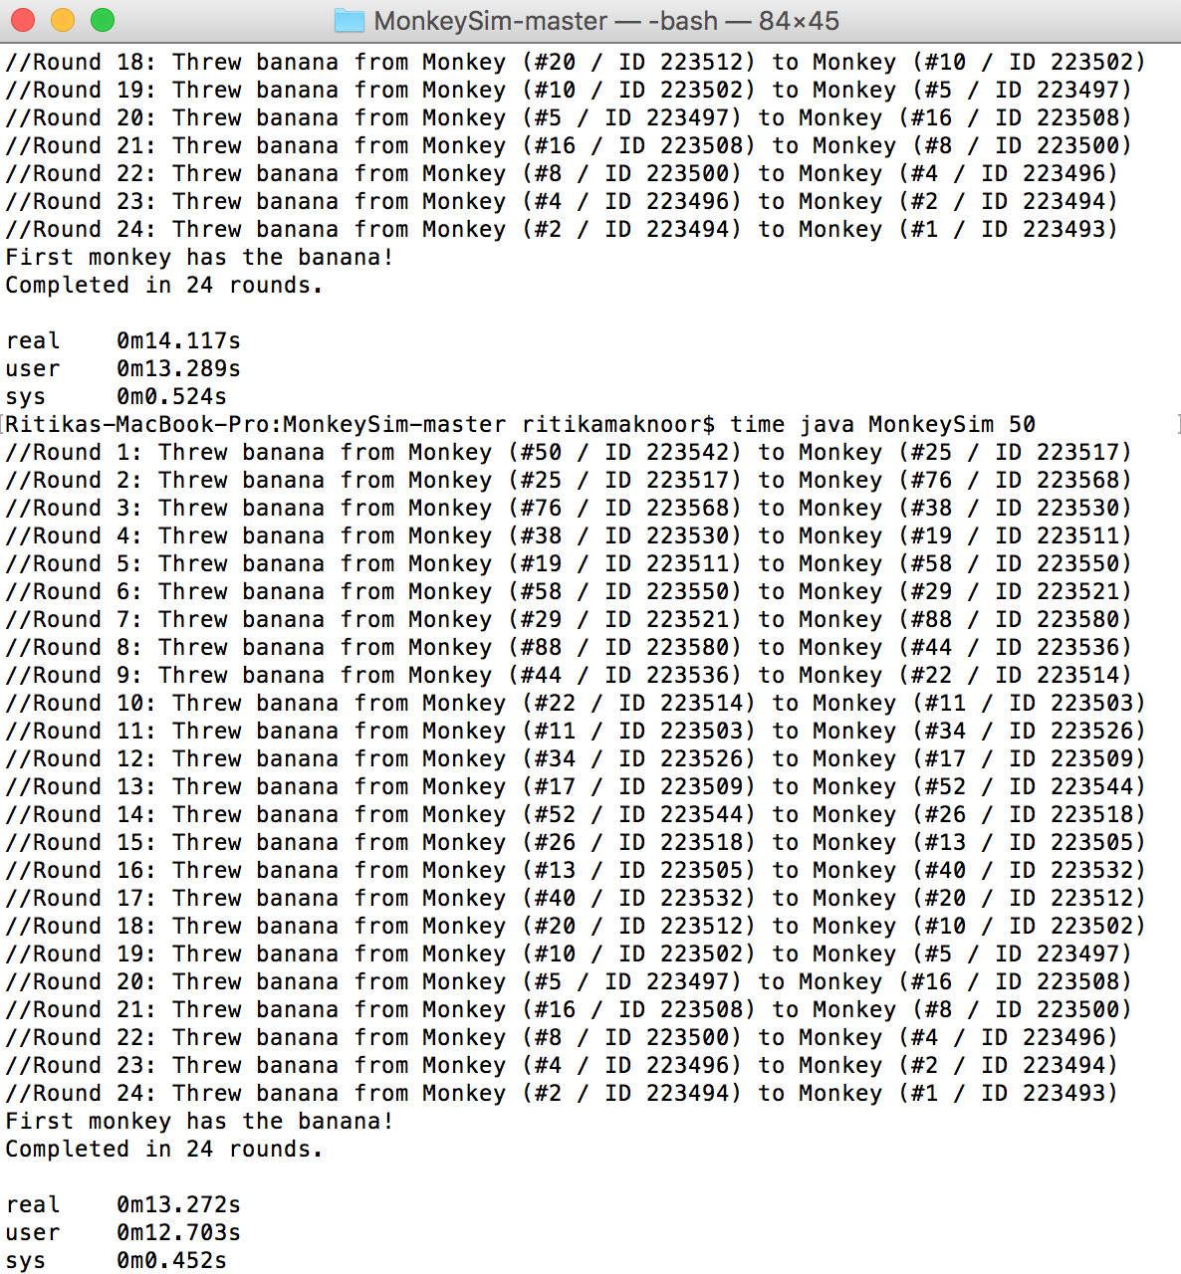

* Max amount of real time: 0m14.343s
* Mean time of real time: 0m13.910s

_________________________________

**AFTER refactoring stringifyResults()**

**Initial monkey: 50**

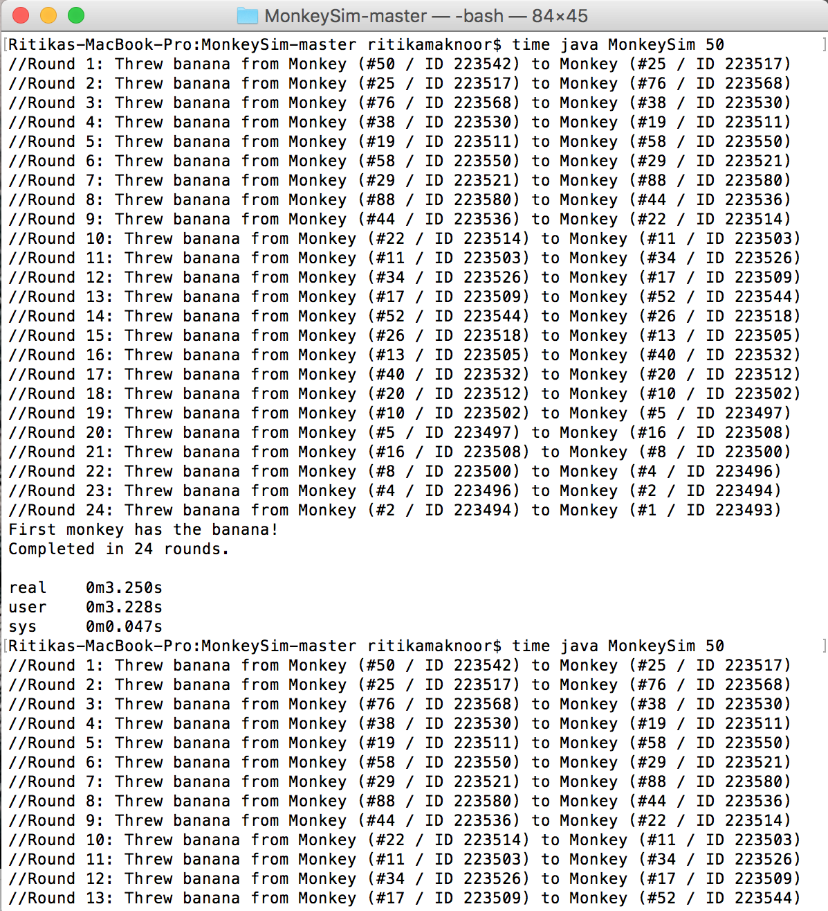

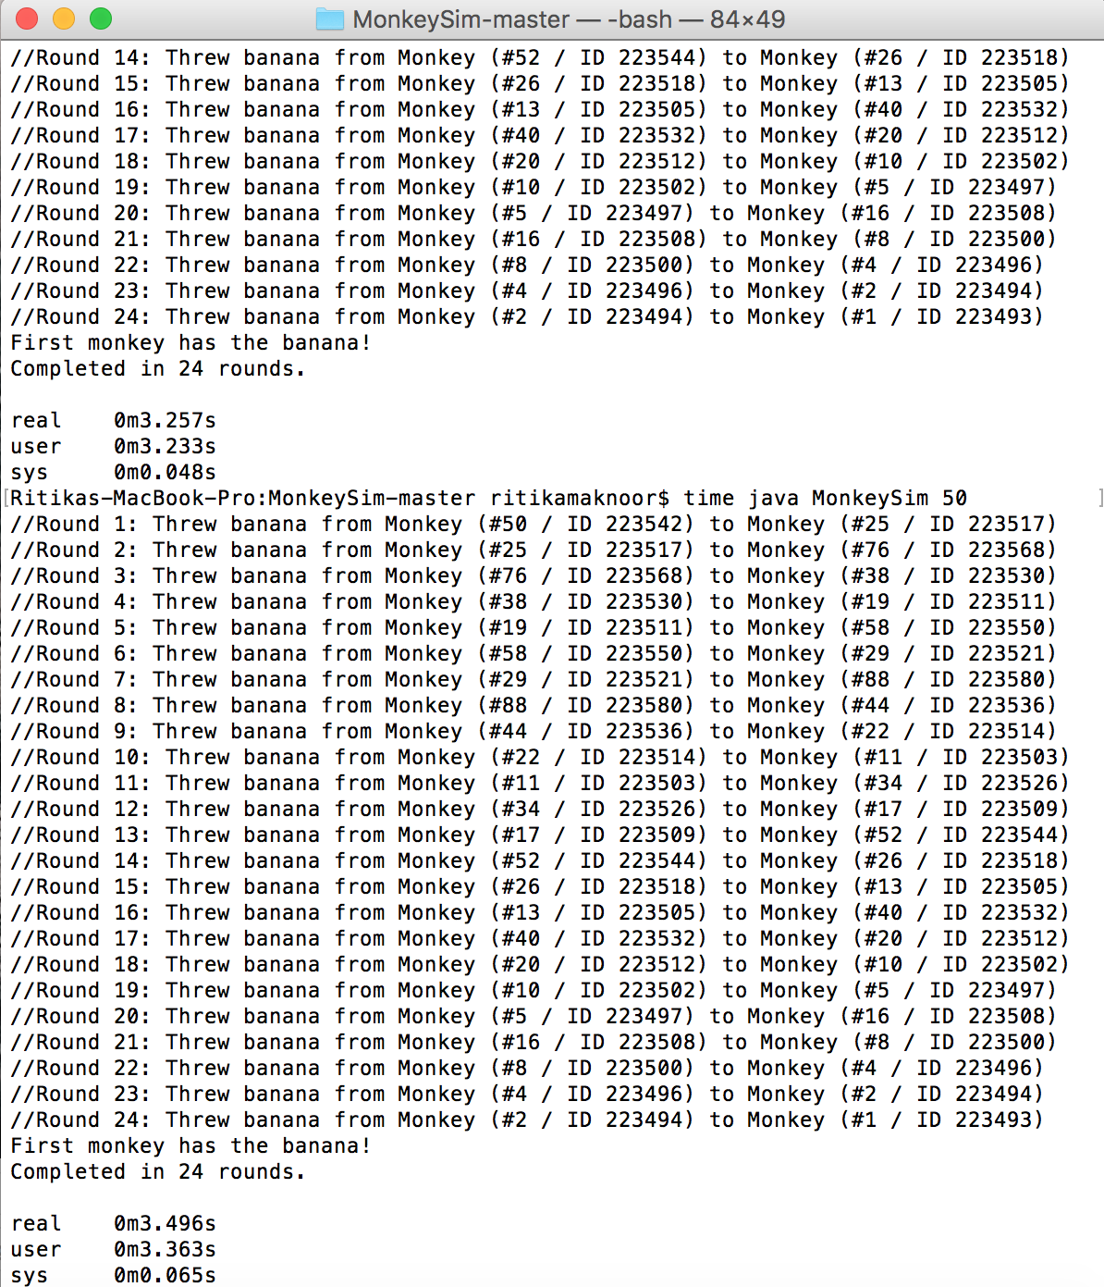

* Max amount of real time: 0m3.496s
* Mean time of real time: 0m3.334s

_________________________________

**AFTER refactoring getFirstMonkey()**

**Initial monkey: 50**

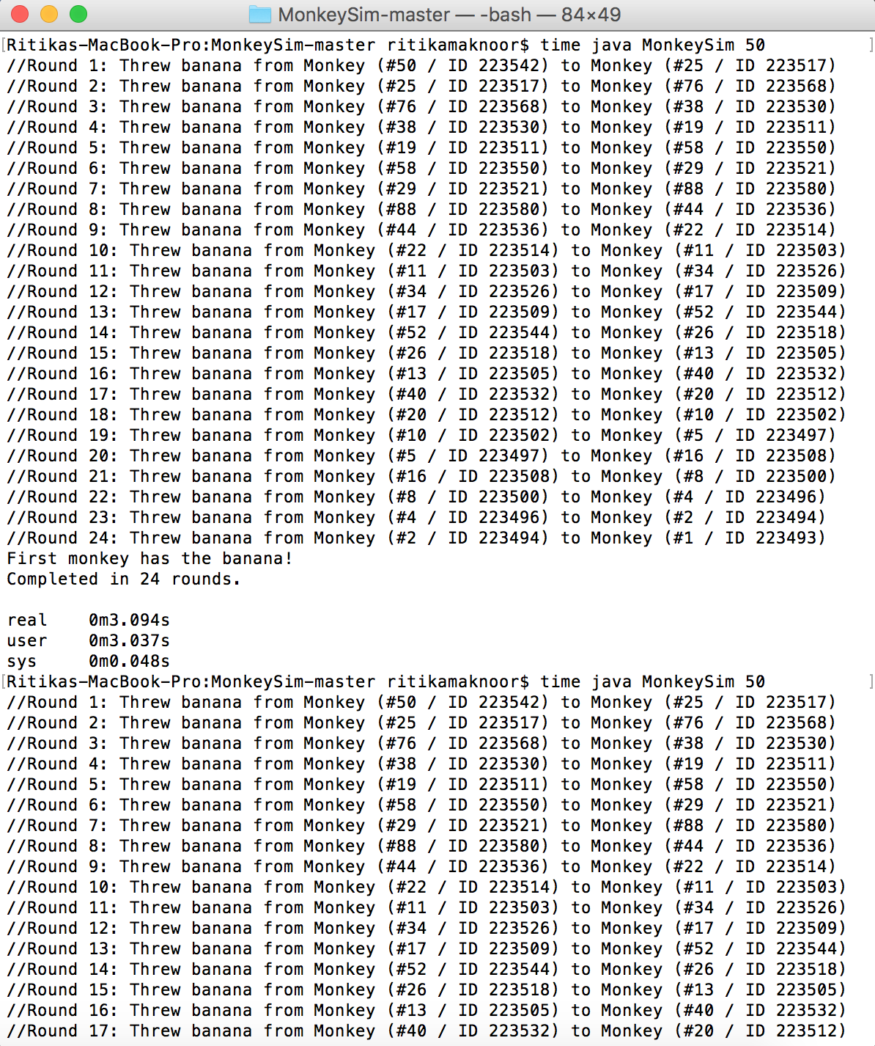

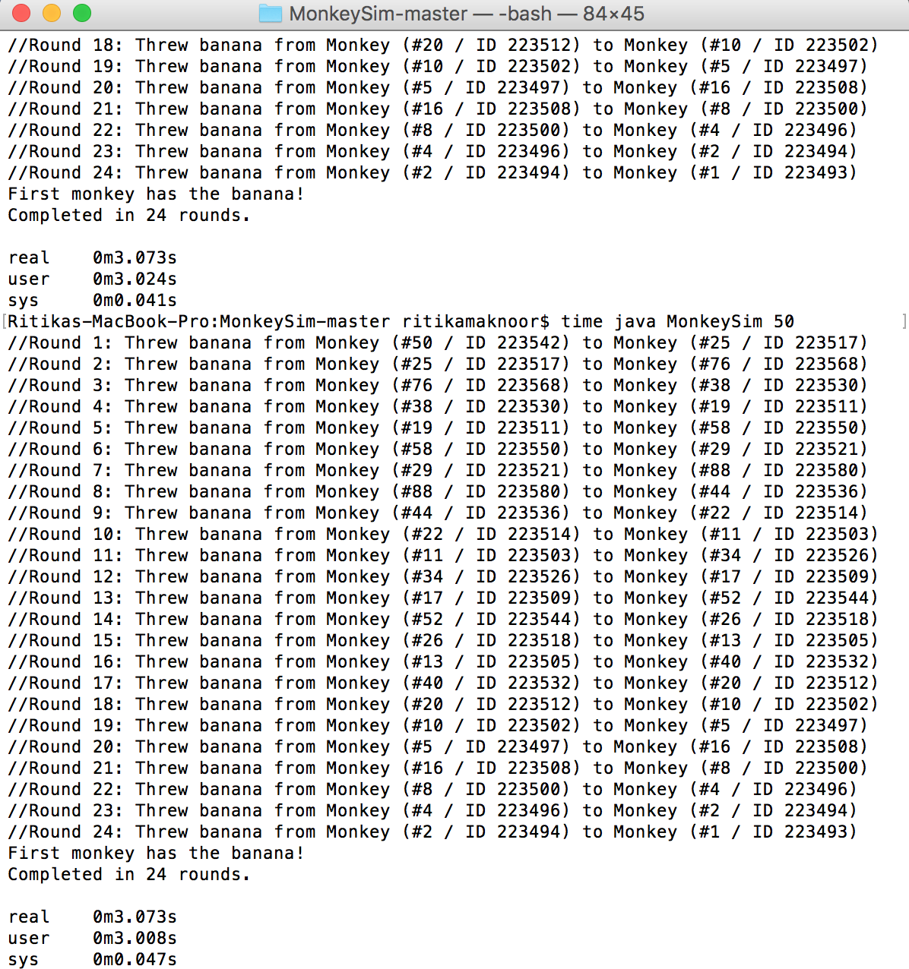

* Max amount of real time: 0m3.094s
* Mean time of real time: 0m3.080s

_________________________________

**AFTER refactoring generateID()**

**Initial monkey: 50**

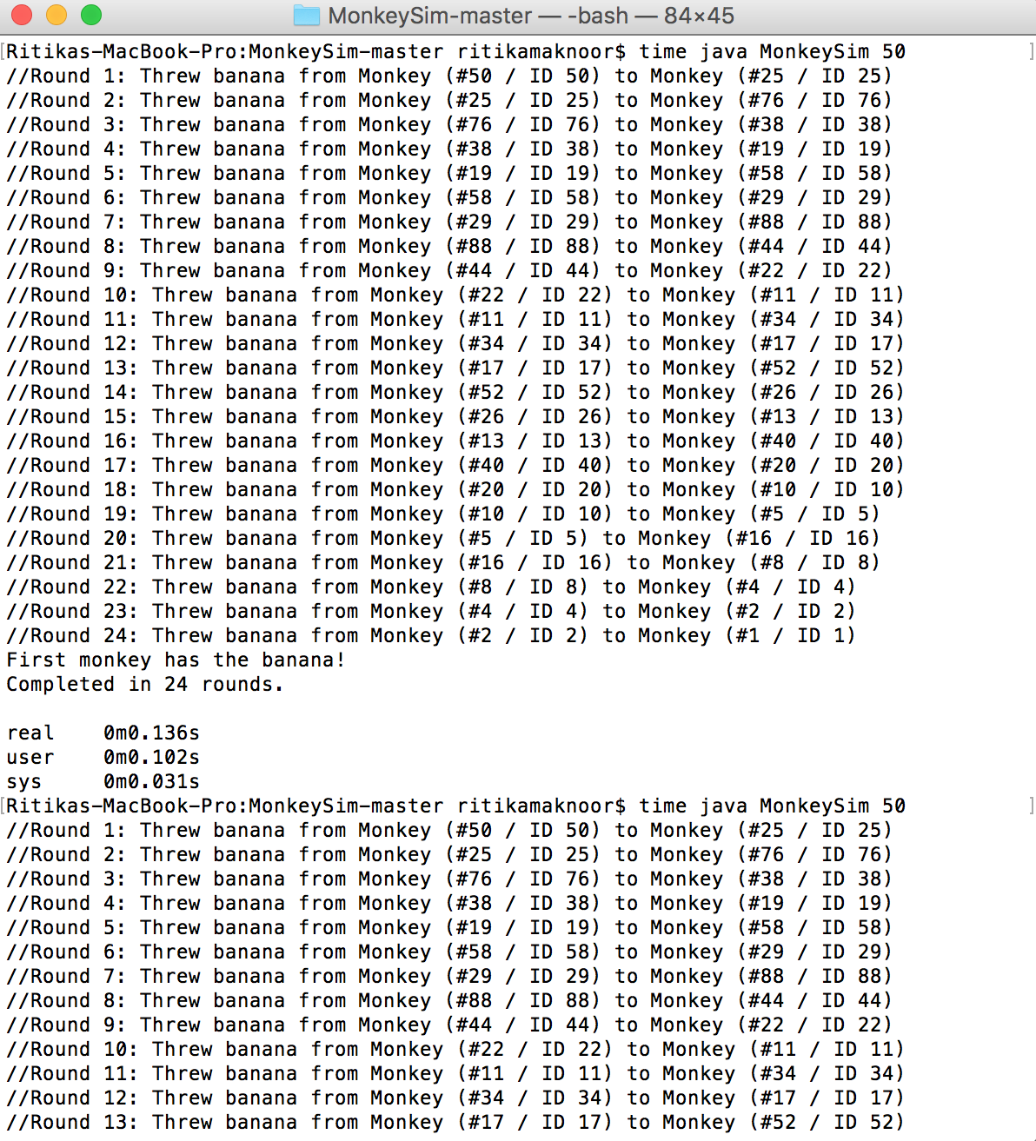

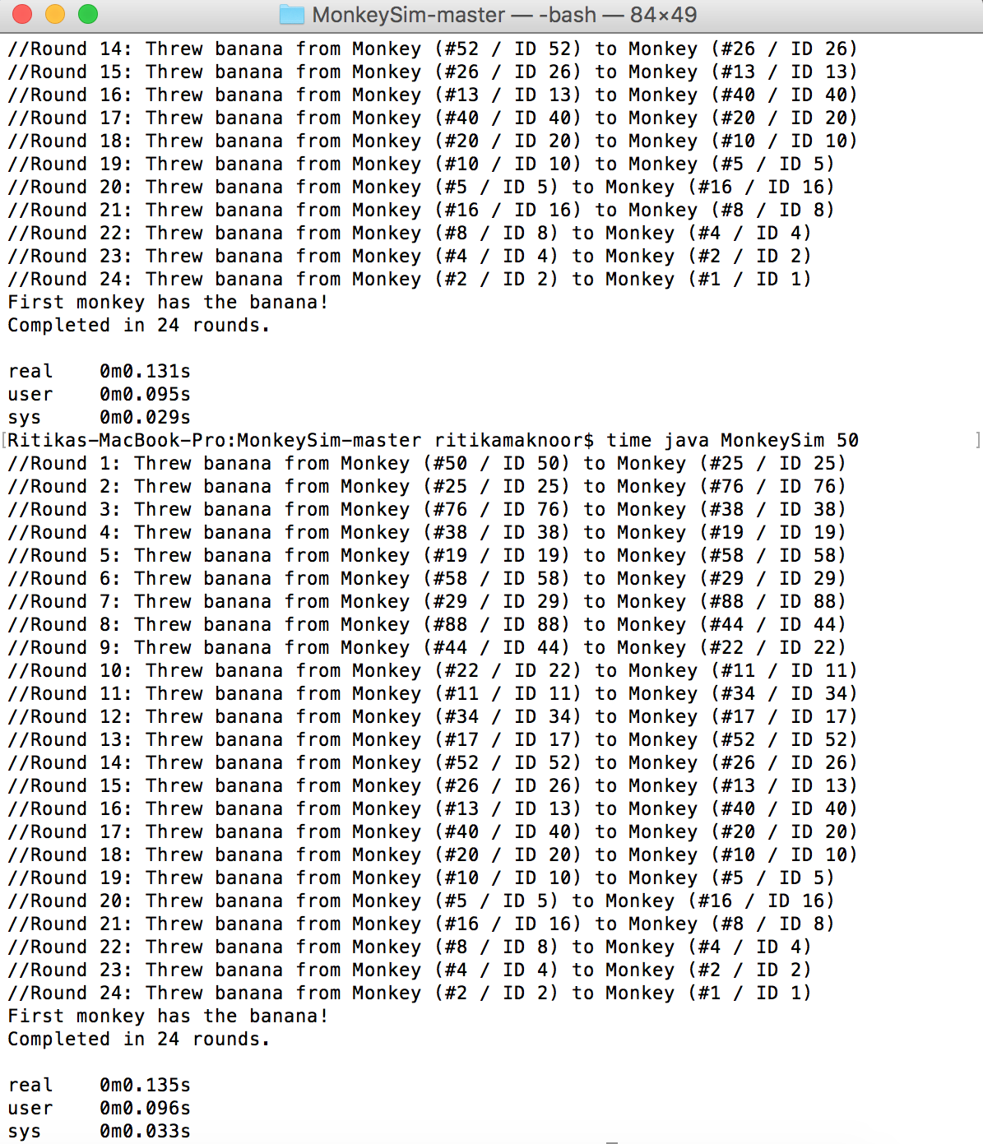

* Max amount of real time: 0m0.136s
* Mean time of real time: 0m0.134s

_________________________________